Don Johnson

CS 585

1 Assignment 11 (100 points)

1.1 Learning Objectives

Understand what data association is and why it is necessary during multi-target tracking

Understand some of the issues that arise when performing multi-target tracking

See one way a Kalman filter can be used for data association during multi-target tracking

1.2 Programming Assignment

1. In the TrackedObject constructor, it sets up a Kalman filter state transition matrix T. You must write down what the matrix is that it constructs, and explain what it means.

This is the transition matrix

$$T=\left[\begin{matrix}1 & 0 & 1 & 0 \\ 0 & 1 & 0 & 1 \\ 0 & 0 & 1 & 0 \\ 0 & 0 & 0 & 0\end{matrix}\right]$$

and the state vector X is

$$X=\left[\begin{matrix}x \\ y \\ v_{x} \\ v_{y}\end{matrix}\right]$$

The product of T and X plus the product of the control matrix and vector (which in this case, there is none) gives the next state

$$TX=\left[ \begin{matrix}x+v_{x} \\ y+v_{y} \\ v_{x} \\ v_{y}\end{matrix}\right]$$

The assumption is the Δt is equal to 1. In this case, it is the time between camera frames. In the program, (x,y) are the coordinates of the detected red object and they are fed into the Kalman filter estimator which handles the “velocity” internally.

2. Spend a little time trying to track more than one object with the given implementation.

Document three undesirable behaviors and speculate about why they arise. One or two sentences per idea is sufficient. Hint: one undesirable behavior to look out for is a "track switch" behavior which will most likely occur when your objects touch or occlude each other. You may elaborate on some of the issues I outlined in the description above.

Undesirable behaviors:

* I used red circles taped to chop sticks for my red object. When I used two and crossed path in opposing arcs, the object would frequently pick up the other object’s path after crossing and occlusion. At the occlusion the detections drops to one, and the tracks drop to one. The first object to be detected when they separate, pick up the first track (blue) and the second object to be detected, even if it formally owned the blue track picks up the green color.
* Object detection fails when the red object is rotated and the visible red area drops below the area threshold.
* My red objects are glossy. A while band of light caused the segmentation algortithm to detect a single red object as two objects and as a consequence, a single object generates two tracks.

3. Fix the data association in trackRedObjects. Make whatever changes to the code you need.

To start, your implementation can work with only two objects. Submit a sequence of five

(possibly non-consecutive) images showing your program tracking through a situation that would cause a track switch with the original implementation.

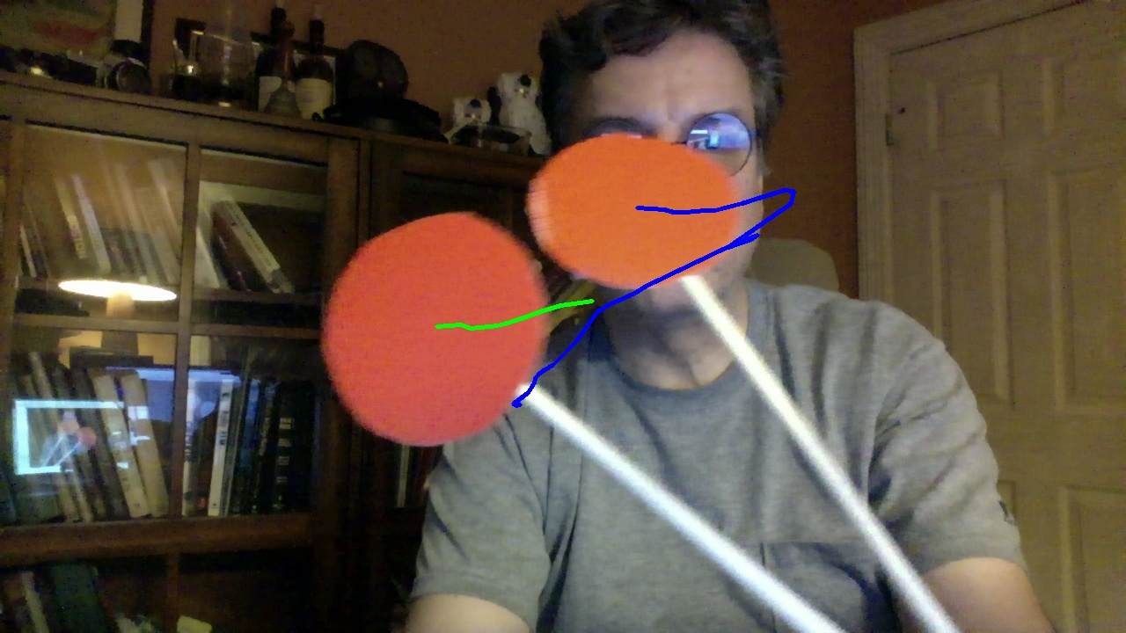

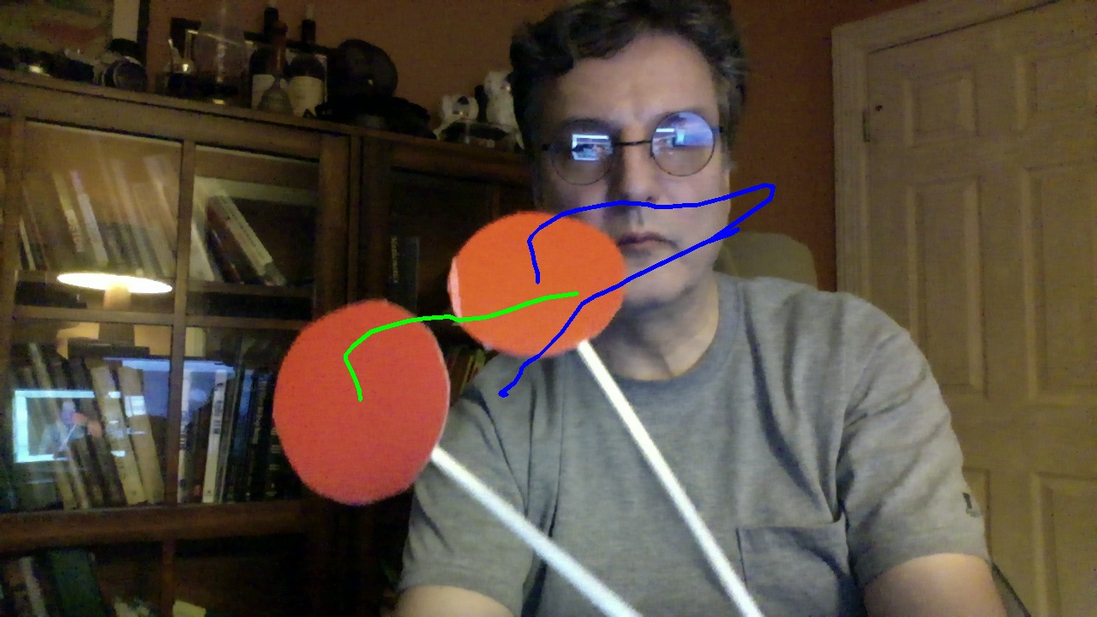

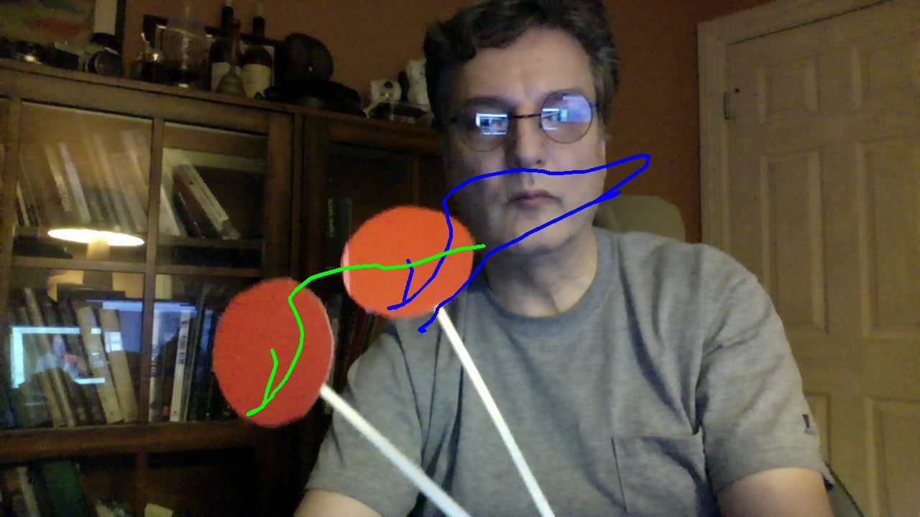

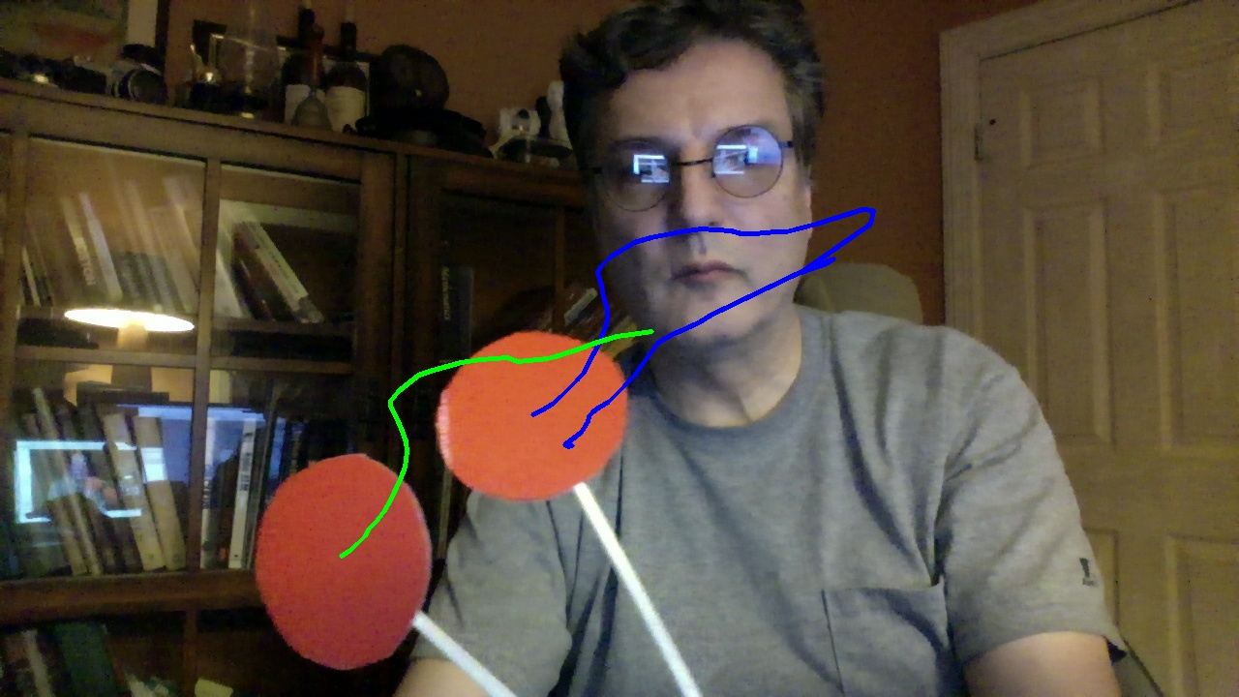

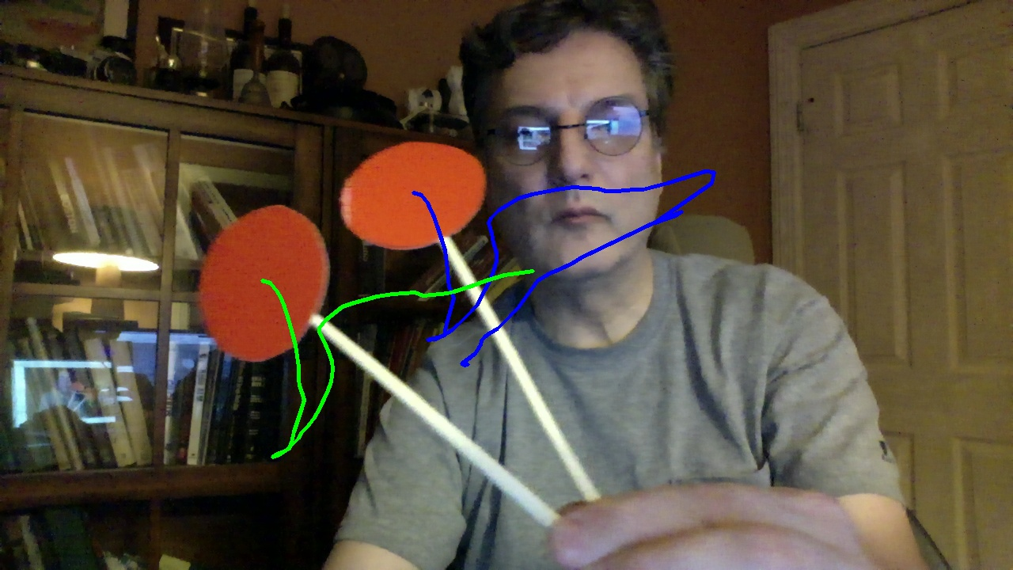

4. Enable track initiation. If there are more detections than tracks at a particular frame, the unclaimed detection should be used to start a new track. Submit a sequence of five (possibly non-consecutive) images showing a situation where there is a track present in the image, and then a new object is introduced, resulting in a new track.





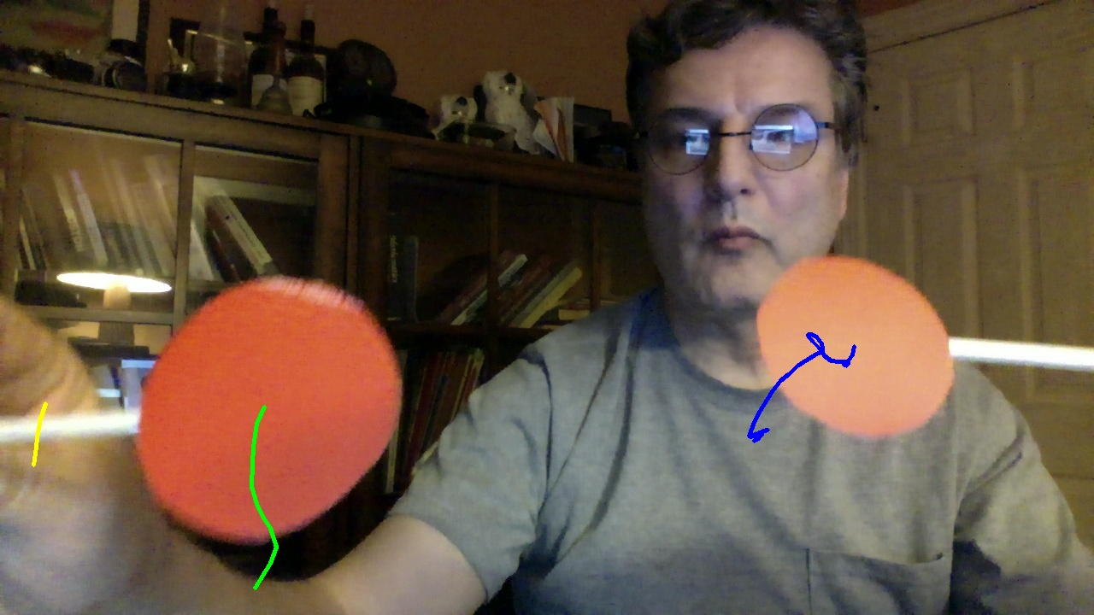

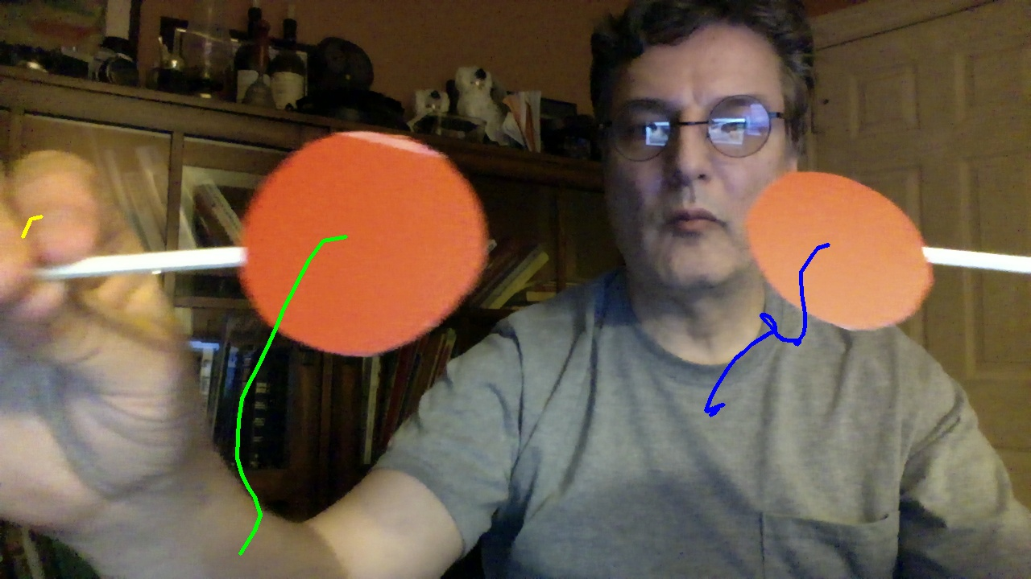

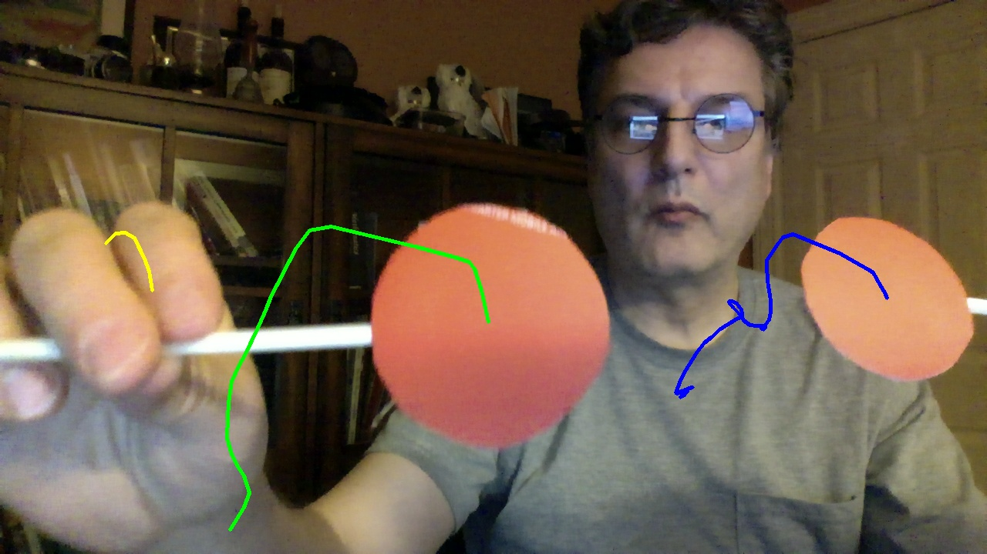

5. Enable track termination. If there are fewer detections than tracks, the track that does not receive a detection should be terminated. Submit an image sequence of five (possibly non- consecutive) images showing two tracked objects, and then one of the tracks disappearing as the object is moved out of the _eld of view.

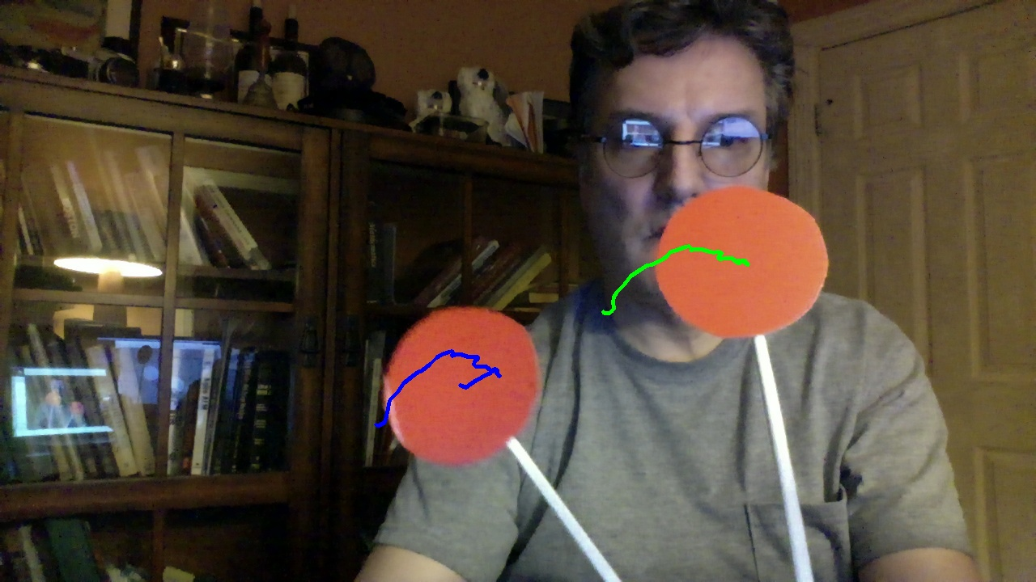



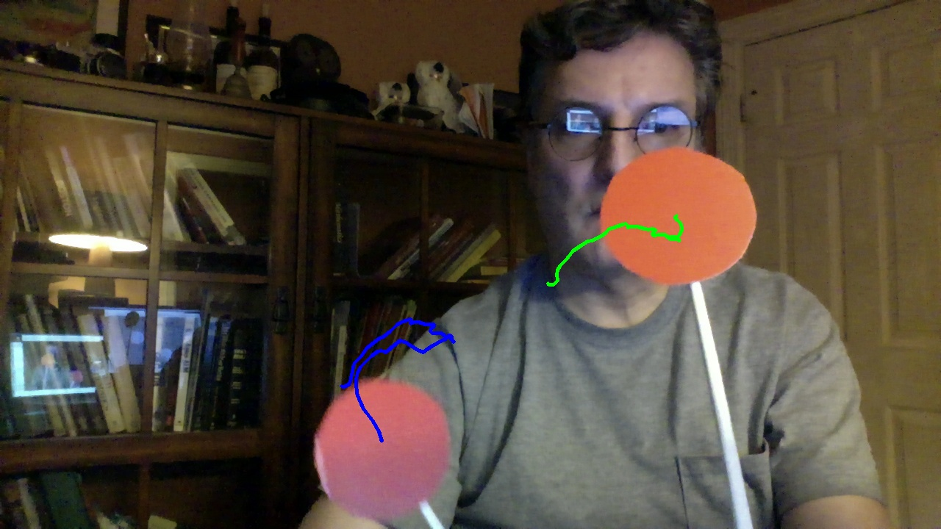





6. Extend your data association to work with up to three tracks and detections. Submit an image sequence of five (possibly non-consecutive) images showing your program tracking 3 objects.



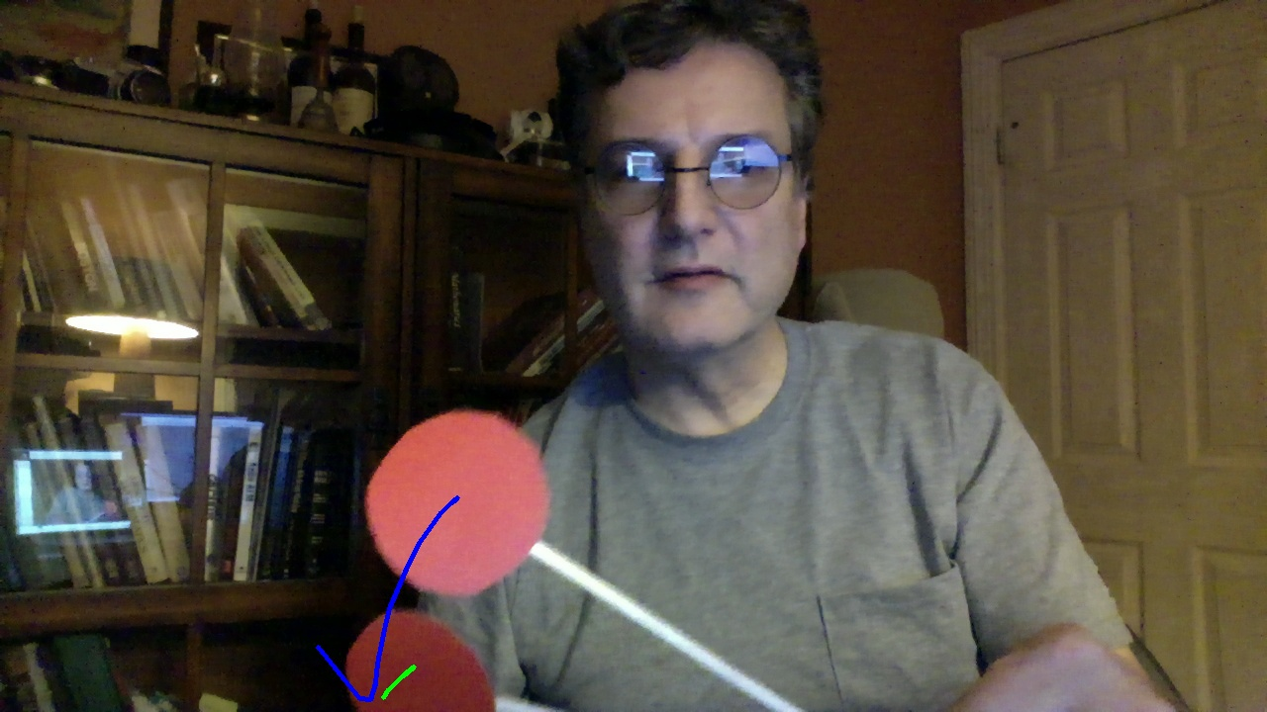

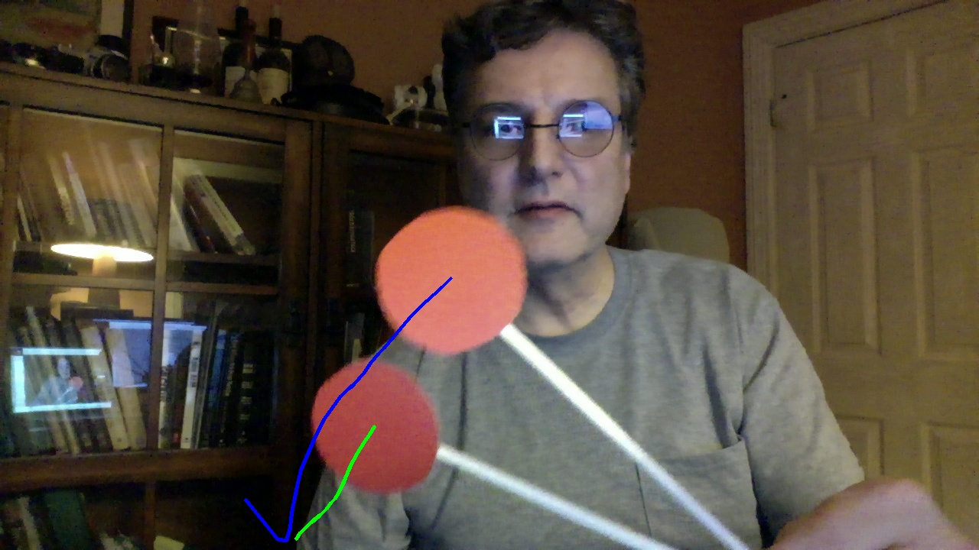

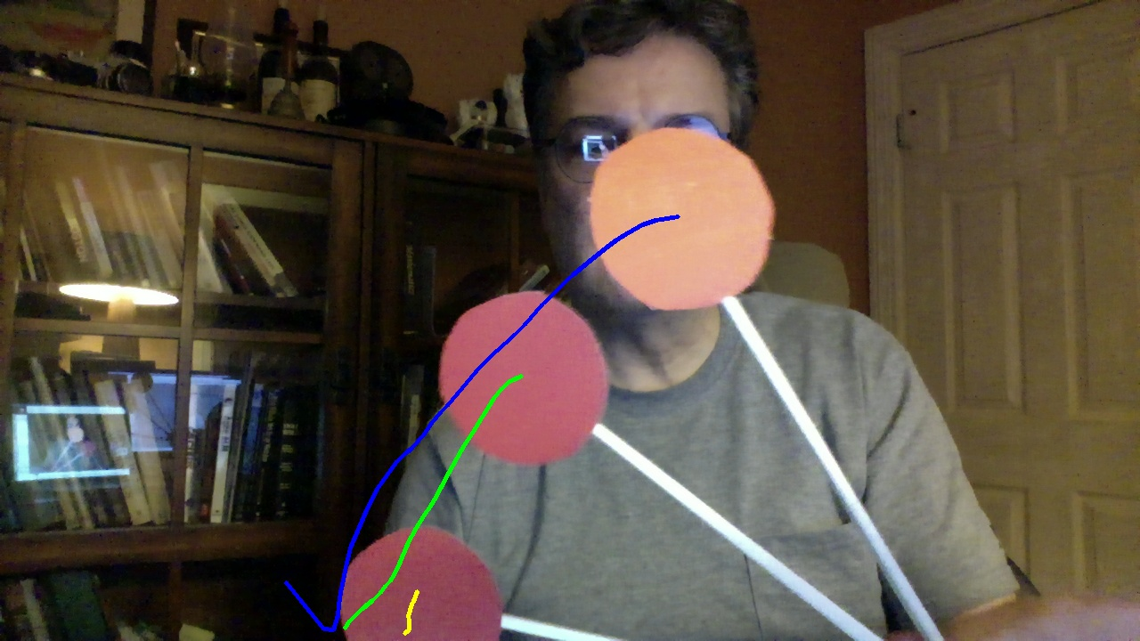

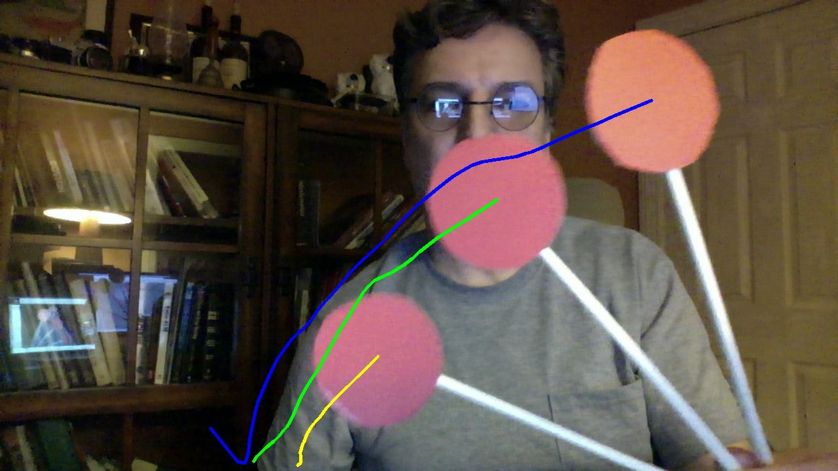

1.3 Lecture Preparation

1. What is the basic idea of the Fourier transform?

In signal processing, the Fourier transform is a mathematical function from time to the frequency domain. In imaging, the Fourier transform is a function the maps from the spatial domain to the frequency domain.